
SMO (A68V)
Catalog Number: CR-M26425
Gene Symbol: SMO; MRD21
Description: Anti-SMO (A68V) Mouse Monoclonal Antibody

Background: Smoothened is a protein that in
humans is encoded by the SMO gene.
Smoothened is a G protein-coupled receptor that is a component of the hedgehog signaling
pathway and is conserved from flies to humans. It is the molecular target of the teratogen
cyclopamine. SMO can function as an oncogene. Activating SMO mutations can lead to
unregulated activation of the hedgehog pathway and cancer
Immunogen: A synthetic peptide from the internal region of SMO which includes the mutation of A68V, human origin.
Tested applications: ELISA, WB, IHC Recommended dilutions:
ELISA: 1:1000-1:5000
WB: 1:500-1:1000
IHC: 1:50-1:100
Concentration: 1 mg/ml
Host: Mouse
Clonality: Monoclonal
Purity: Purified from ascites
Format: Liquid Storage buffer:
Preservative: no
Constituents: PBS (without Mg2+ and Ca2+), pH 7.4, 150 mM NaCl, 50% glycerol
Species Reactivity: Recognizes A68V mutant, but not wild-type SMO of vertebrates.
Storage Conditions: Store at -20°C. Avoid freeze / thaw cycles.

Western blot:
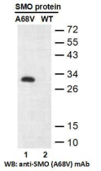
Western blot analysis of recombinant SMO (A68V) and wild-type proteins.
Purified His-tagged SMO (A68V) protein (lane 1) and corresponding wild-type protein (lane 2)
were blotted with anti-SMO (A68V) monoclonal antibody (Cat. #26425).

For research use only. Not for diagnostic or therapeutic applications.

Immunofluorescence:
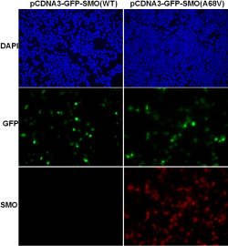
Immunofluorescence of cells expressing SMO proteins with anti-SMO (A68V) antibody.
HEK293T cells were transfected with
pCDNA3-GFP-SMO (WT) plasmid (left column) or pCDNA3-GFP-SMO (A68V) plasmid (right
column), then fixed and stained with
anti-SMO (A68V) monoclonal antibody (Cat.
#26425).

